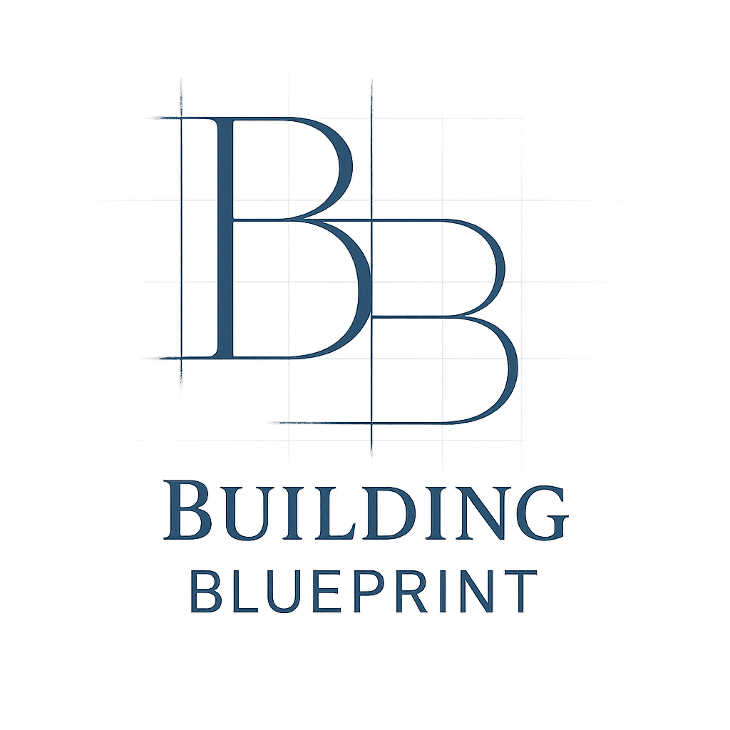
Entity Decision Matrix
This matrix is designed to help you compare the most common legal ownership structures for a custom home build. Use it to evaluate the pros and cons of each path based on your personal financial situation, risk tolerance, and project goals. Disclaimer: This is an educational tool, not legal or tax advice. You must consult with a qualified attorney and CPA to choose the right entity for your specific circumstances.
Project Title: _______________________________________________________________
Date: _______________________________
Ownership Option | Liability Protection | Impact on Financing | Key Tax Implications | Setup Cost & Complexity | Ongoing Compliance
Personal Ownership | None. Your personal assets (home, savings, etc.) are at risk from lawsuits related to the project. | Easiest. Lenders are most familiar with this path; standard residential mortgage process. | Simple. Capital gains on the sale of a primary residence are largely excluded. Mortgage interest is deductible. No depreciation benefits. | None. This is the default ownership structure with no setup cost or complexity. | None. No special filings or fees are required.
Single-Member LLC (SMLLC) | Good. Creates a "corporate veil" to shield personal assets from project liabilities (e.g., subcontractor lawsuits), provided formalities are followed. | More Complex. Lenders often treat this as a commercial loan, which may have higher rates. A personal guarantee will almost always be required, making you personally liable for the loan itself. | Flexible. A "pass-through" entity by default (income/loss reported on your personal return). Can allow for depreciation if it's an investment property. | Moderate. Requires state filing fees, creating an operating agreement, and potentially a registered agent fee. | Moderate. Requires annual state reports/fees and maintaining a separate bank account and records is critical to preserve the liability shield.
Multi-Member LLC / LP | Good. Shields the personal assets of all members/partners from business debts and lawsuits. | Commercial Loan. All members will likely need to provide personal guarantees. Can be harder to coordinate among partners. | Partnership Taxation. Requires a separate partnership tax return (Form 1065). Allows for complex profit/loss allocations between partners, but requires more accounting. | High. Requires a robust, attorney-drafted operating/partnership agreement to define roles, contributions, and exit strategies. | High. Requires strict financial separation, annual filings, and partnership tax returns.
S-Corporation | Good. Provides a strong liability shield for shareholders, similar to an LLC. | Commercial Loan. Similar to an LLC, lenders will require personal guarantees from shareholders. | Pass-through. Can offer self-employment tax savings if you pay yourself a salary (less common for a one-off build). More rigid profit/loss rules than an LLC. | High. More formal than an LLC, requiring bylaws, issuing stock, and holding board meetings. | Highest. Requires strict adherence to corporate formalities, including regular meetings, keeping minutes, and corporate tax filings.
Notes: ___________________________________________________________________

